CS Assignment
Name
Institution
Instructor
Date

- A computer in a LAN with Private IP address 10.4.4.65 wants to access a web server on internet with destination IP address 200.53.25.67. The gateway of LAN is a router with Public IP 130.50.60.8. (10 marks)
  - How this computer can access web resources on internet? Write the technique and explain in detail in your own words?
Computers connect and communicate using Transmission Control Protocol/ Internet Protocol (TCP/IP). The protocol suit outlines the rules and step by step guide on how each computer should transmit and receive data over a network. A computer in a LAN can access the internet and communicate with other computers and servers on the internet using a public IP address of the network. Private addresses are only used for communications within the LAN and cannot be used to directly access a resource on the internet. The computer with private IP address 10.4.4.65 wants to access resource available in the internet; it compares the destination’s network address with what is on its own local routing table. Since the network address is not within the same LAN, it sends a request to the default gateway. The gateway is the router that connects the LAN to the internet. The router gets the public IP address of the remote host - 200.53.25.67 and searches for the location of the destination in the routing table. The router sends the request to the Internet Service Provider’s (ISP) gateway with its own public IP address. The ISP gateway then determines the next hop (another router) in the route to the destination. It thus sends the request to the next router since it does not know the exact location of the resource. The request is forwarded through a number of routers until it gets to the exact host. The host on the internet processes the request and gives a response that travels back from its gateway to a router closer to the LAN router-130.50.60.8. the response also goes through multiple routers until it finally gets to the LAN gateway. Once the router receives the response it knows which host made the request and it sends the packets received to the requesting host.
  - The same computer with IP 10.4.4.65 wants to send data within LAN to a computer with IP 10.4.4.89. How the source computer can get the physical address of that computer? Write the protocol and explain in detail in your own words?
Hosts often send and receive packets of data within the same network with the help of a protocol called Address Resolution Protocol. For the computer with IP 10.4.4.65 to communicate with the other computer which has an IP address 10.4.4.89 it uses its local routing table to determine the destination host. ARP maps specific private IP addresses to the MAC address of individual computers. When a host is assigned a private address ARP then maps the assigned address with the specific MAC address of the Network Interface Controller of the host. The computer stores the mapping on its ARP table. The host also creates a routing table which stores the IP addresses and physical addresses assigned. It also stores the subnet mask and the default gateway for sending packets to hosts outside the broadcast domain. The host with IP address 10.4.4.65 will confirm that the destination computer is within the same subnet by comparing IP address and subnet mask of the target host with its own. Once it has determined they are on the same broadcast domain it then checks its ARP table for the physical address mapped to the IP address 10.4.4.89. The source computer can now send data frames to the other computer. The recipient host will also check to confirm that it is within the same broadcast domain with the sender before it can send a response. Once it determines they are both on the same network, it checks for the physical address of the source from its own ARP table and sends the response and a two communication is established.
  - The network administrator of above LAN is tired of manually giving IPs to this LAN of 200 computers? Suggest an application to make his job easy?
Assigning IP addresses manually is tiresome and is prone to human errors especially with a large network. Managing 200 computers and their addresses together with other network configuration information can be automated save for few reserved static addresses for critical network resources. Dynamic Host Configuration Protocol (DHCP) is a very useful system that can manage IP addresses and other network configurations. Computers in the network obtain their individual addresses dynamically through DHCP. When a computer is powered on and has a wireless or Ethernet connection to the network DHCP assigns it an IP. When the computer goes off, it releases the address to the address pool of the DHCP server. With a DHCP sever installed on the LAN, the network administrator will only have to assign static address to critical resources in the network such as servers and the 200 computers will dynamically obtain the address and thus making work easier and less prone to errors.
- In below diagram, Host 1 want to send data to Host 3. Write the steps which Host 1, Router1, Router 2 and Router 3 will do to send the data to Host 3? (5 marks)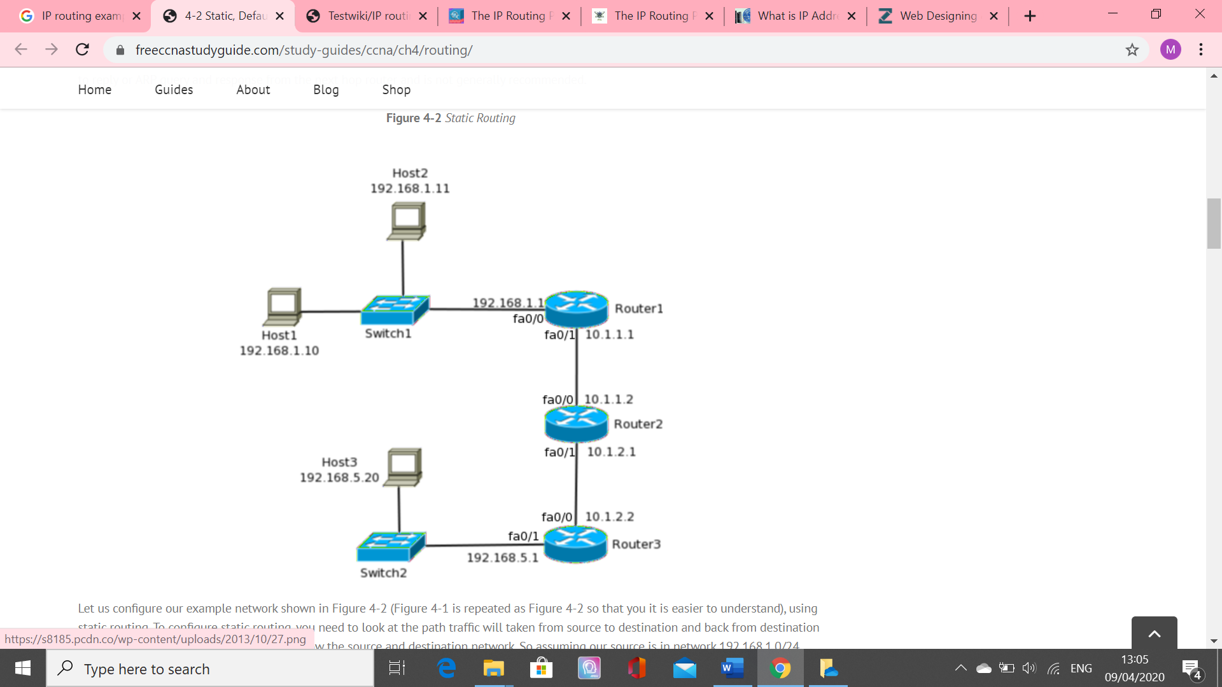
Host 1 and host 3 are not on the same physical network and data will have to be send through the default gate way. Host 1 will check its ARP table to see if host 3 is in the same broadcast domain. By comparing its own IP address and subnet mask with those of host 3, it will determine that they are on different physical network. Host 1 then sends the data to the default gateway which is router 1. From its ARP table router 1 checks and realizes that host 3 is on a different network. Router 1 checks its routing table to establish the destination route since the target computer is not within its physical network. Router 1 will determine the route to the destination and figures that the next router to send the data is router 2. When router 2 receives the packets, it checks its routing table for the destination address and determines that the data is meant for router 3 network. It forwards the frames to router 3. Router 3 receives the data and checks if the destination host is within the local network. It determines that the host is on the local network by comparing the network address with what it has on the routing table. Router 3 then checks for the physical address mapped to the IP address of host 3 from its ARP table. The router finally sends the data to the destination host within its local network.

